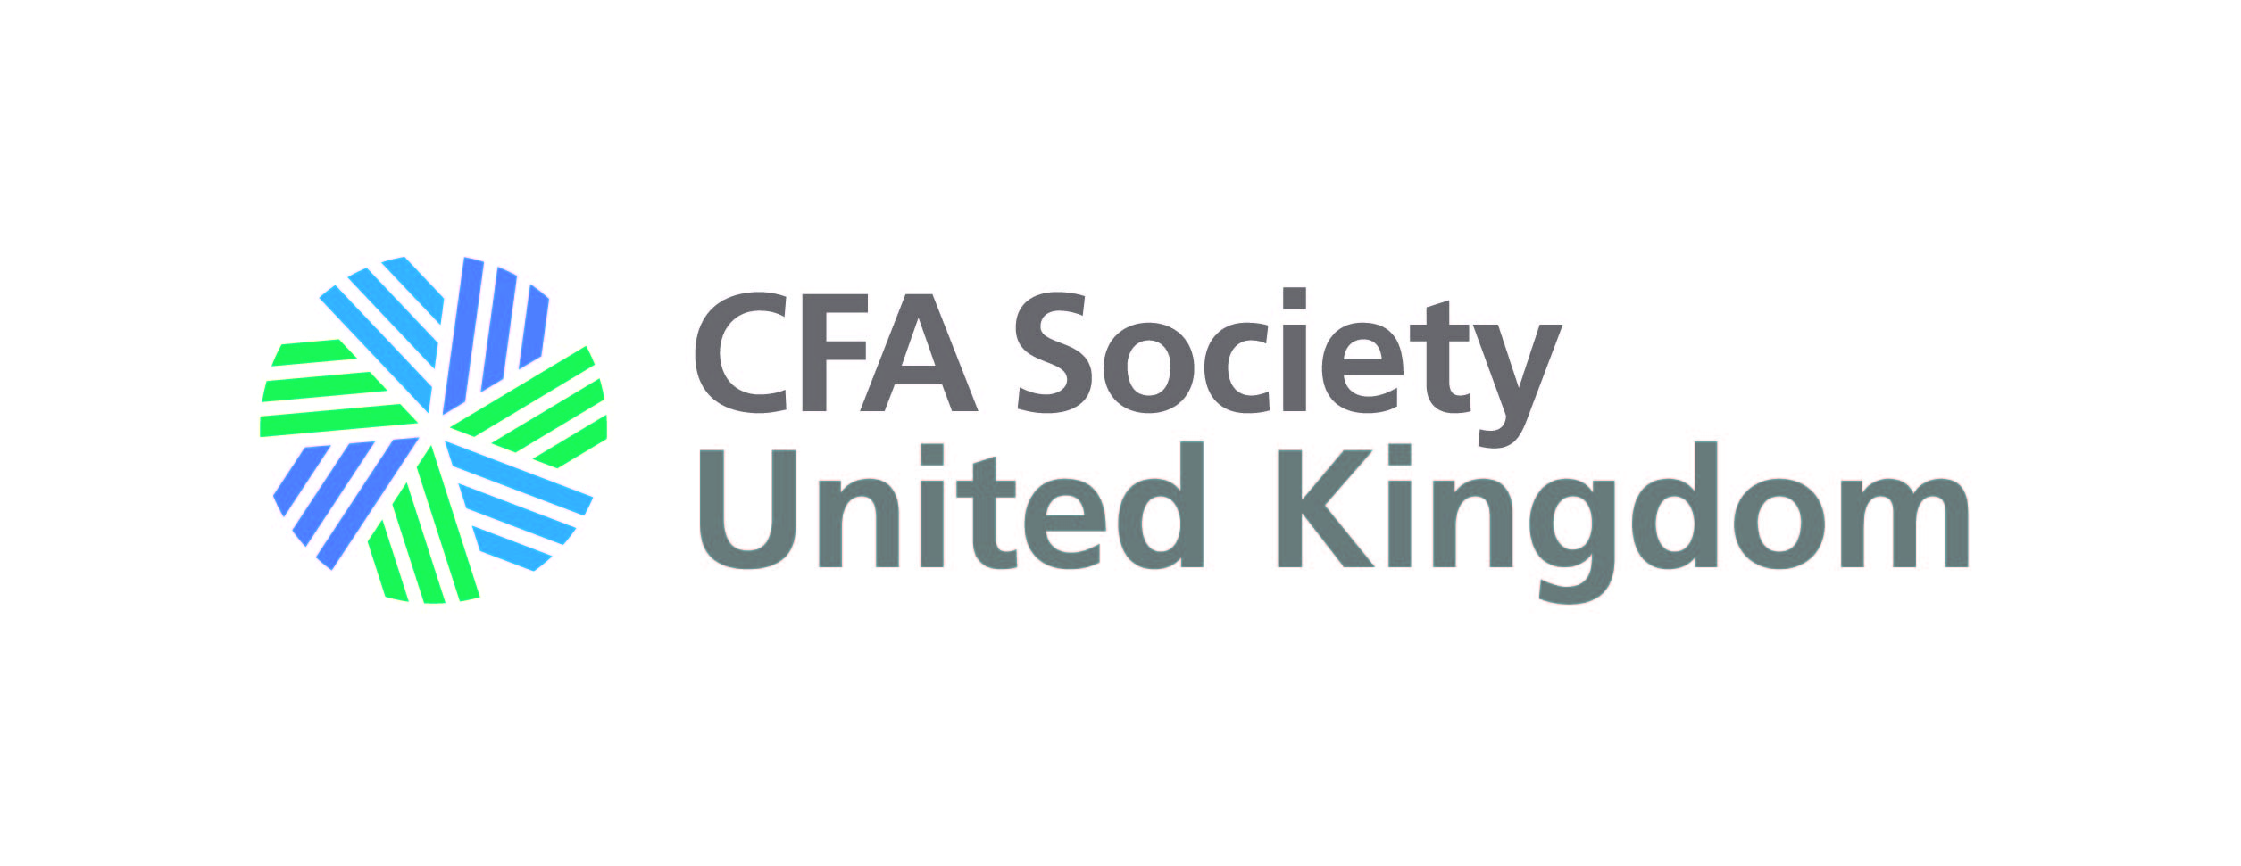

Volunteer Awards 2017
Category: Outstanding Volunteer Group of the Year

This award is open to any group of volunteers (excluding Board and Fellows) such as committees, councils, panels, working groups, social media advocates, special project groups etc. This group must have worked together and made an impact in the last year and a half in the run up to the Volunteers’ Reception on 7th November 2017.

Nominating process
- Submit completed nomination form to volunteer@cfauk.org by 20th October 2017
- A working group of volunteers and staff will short list nominations in each category.
- An independent awards panel consisting of the Chairman and volunteers from the Volunteer Experience Project group will then select the winners from the shortlist.

To nominate in this category please complete all sections of this form
Deadline for nominations: 20th October 2017

Your name: | Your name
Nominee name: | Name of volunteer group
Please explain how this nominated volunteer group has demonstrated outstanding commitment to delivering their group aims and has helped CFA UK to build a better investment profession.

In answering, you may want to demonstrate how this group has made a strong impact by improving member services or by furthering the society’s mission. Maybe they have led the way in creating strong partnerships across the membership and volunteer communities. They may have produced outputs that have supported the development of individual members or of the profession as a whole. This volunteer group should work together in an engaging way with strong contributions from across the team and an ability to work collaboratively.

Why you are nominating this group

